No. | String
1 | #ffffff,#cfcecf,//////////
2 | #81BEF7,#045FB4,
3 | #D8D8D8,#120A2A,
4 | #424242,#120A2A,oo
5 | #FFFFFF,#120A2A,.....
6 | #6f6d6d,#504d4d,
7 | #48D1CC,#008B8B,/////
8 | #EEE8AA,#BDB76B,
9 | #C0C0C0,#808080,
10 | #90EE90,#006400,oo
11 | #4169E1,#191970,.....
12 | #B0C4DE,#708090,
13 | #FA8072,#CD5C5C,/////
14 | #9ACD32,#556B2F,
15 | #E0FFFF,#AFEEEE,----
16 | #ADD8E6,#1E90FF,oo
17 | #A9A9A9,#696969,.....
18 | #EEE8AA,#BDB76B,
19 | #ADD8E6,#1E90FF,/////
20 | #FFC0CB,#FF69B4,
21 | #F0F8FF,#708090,----
22 | #EEE8AA,#BDB76B,oo
23 | #90EE90,#8FBC8F,.....
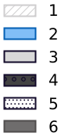  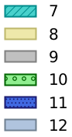  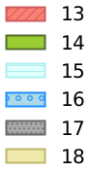  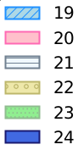  24 | #4169E1,#191970,

